Coding & Solution
Date | 01 October 2026
Team ID | SWTID-2026-2351
Project Name | Auto Ticket Classification using Flow Designer
Maximum Marks | 5 Marks

Coding & Solution
The solution is built with ServiceNow low-code tools (Table, Form Builder, Flow Designer), so the "code" is the configuration captured in the Project Update Set.

Solution Summary
Repository Link / URL | Project Update Set exported as XML (see Project Executable Files). Add your GitHub / Drive link here if you upload it.
Programming Language(s) | No custom code. Platform configuration; the Number field uses the platform default javascript:global.getNextObjNumberPadded();
Framework(s) Used | ServiceNow (Form Builder, Flow Designer / Workflow Studio, Update Sets)
Key Features Implemented | - Incident Workflow table with INC auto-numbering.  - Category, Subcategory (dependent) and State choice lists.  - Flow "Auto Classify School IT Tickets" (trigger: Category is empty).  - Confirmation email through Send Email.  - Update Set completed and exported.
Pending / Incomplete Features | Assignment to Assigned Group by category and a ticket dashboard are planned for a later phase.
Setup / Run Instructions | - Log in to the ServiceNow instance as admin.  - Import and commit the Project Update Set XML (or recreate the steps in the report).  - Open Incident Workflow > New, choose a Category, enter the Short Description and Submit.  - Check the record and the Email Log to see the classification and confirmation.

Implementation Evidence
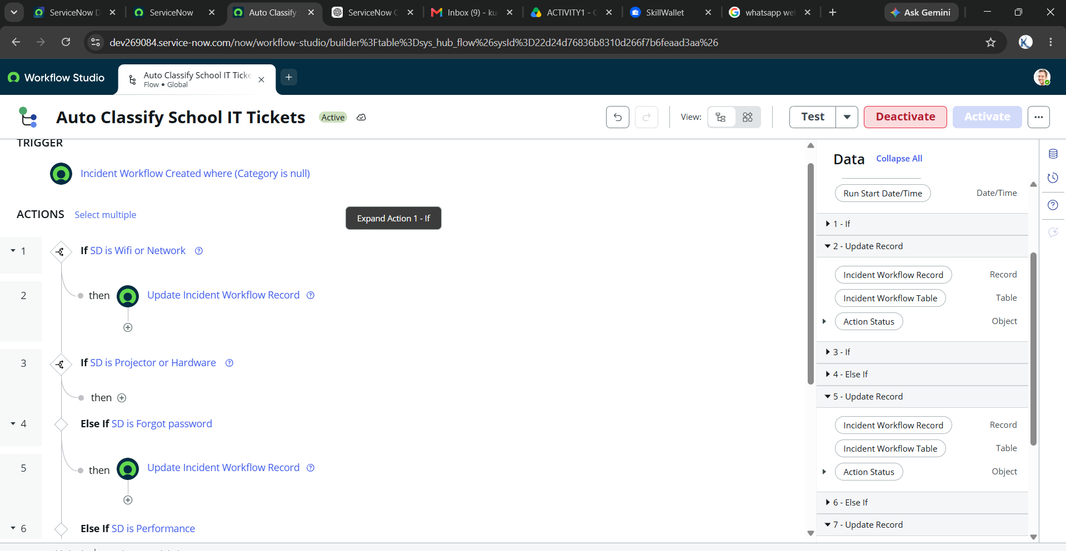
Figure 1: Flow "Auto Classify School IT Tickets" (trigger and If / Else If actions)
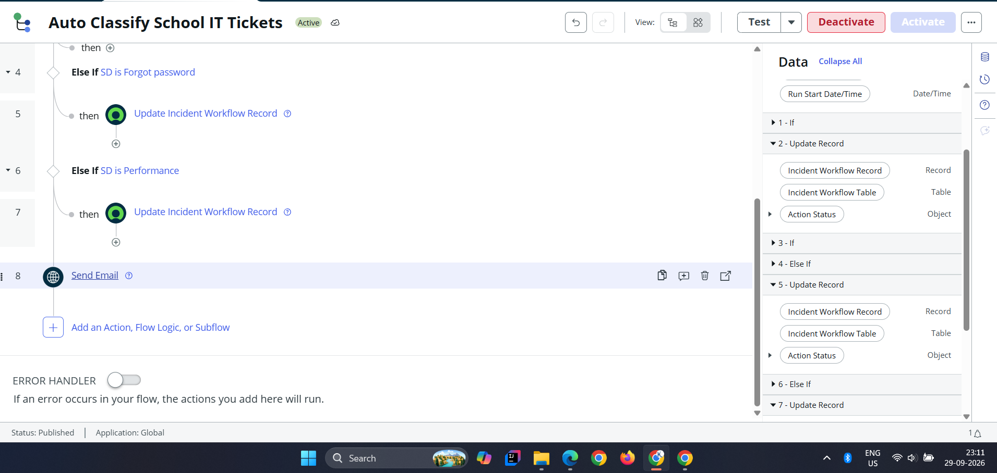
Figure 2: Remaining actions and Send Email
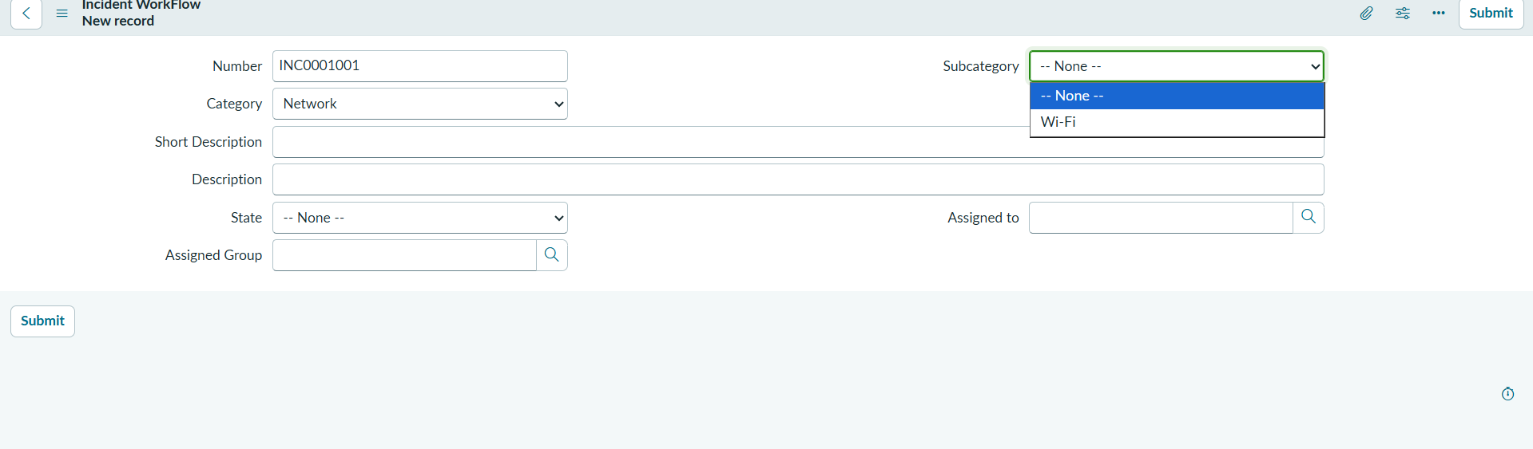
Figure 3: Dependent Subcategory (Category = Network shows Wi-Fi)

Code Quality Checklist
S.No | Criteria | Status (Yes / No)
1 | Code is modular and organized into functions / classes (flow logic split into clear If / Else If branches) | Yes
2 | Meaningful variable and function names are used (table, field and flow names) | Yes
3 | Code includes comments / documentation where necessary | Yes
4 | Error handling is implemented for critical operations | No (flow error handler is off)
5 | The application runs without critical errors | Yes
6 | Code is committed to a version control repository (Update Set) | Yes

Additional Notes / Comments
Flow is Active and Published in the Global application scope. Enabling the flow error handler is suggested as a next improvement.

